# Brainstorm

**TIP**

You can select a sticky note and hit the pencil [switch to sketch] icon to start drawing!

## Before you collaborate

A little bit of preparation goes a long way with this session. Here’s what you need to do to get going.

**10 minutes**

**1**

## Define your problem statement

What problem are you trying to solve? Frame your problem as a How Might We statement. This will be the focus of your brainstorm.

**5 minutes**

**2**

## Brainstorm

Write down any ideas that come to mind that address your problem statement.

**10 minutes**

**3**

## Group ideas

Take turns sharing your ideas while clustering similar or related notes as you go. Once all sticky notes have been grouped, give each cluster a sentence-like label. If a cluster is bigger than six sticky notes, try and see if you and break it up into smaller sub-groups.

**20 minutes**

**4**

## Prioritize

Your team should all be on the same page about what's important moving forward. Place your ideas on this grid to determine which ideas are important and which are feasible.

**20 minutes**

## After you collaborate

You can export the mural as an image or pdf to share with members of your company who might find it helpful.

**Quick add-ons**

# & idea prioritization

Things our

Creating a cloud

### Use this template in your own brainstorming sessions so your team can unleash their imagination and start shaping concepts even if you're not sitting in the same room.

**10 minutes** to prepare

**1 hour** to collaborate

**2-8 people** recommended

1. **Team gathering**

Define who should participate in the session and send an invite. Share relevant information or pre-work ahead.

1. **Set the goal**

Think about the problem you'll be focusing on solving in the brainstorming session.

1. **Learn how to use the facilitation tools**

Use the Facilitation Superpowers to run a happy and productive session.

[**Open article**](https://support.mural.co/en/articles/2113740-facilitation-superpowers)

**PROBLEM**

**to avoid long distance travel for attending interview.**

**to avoid frustation of candidates for lookingup**

**for job**

**Key rules of brainstorming**

To run an smooth and productive session

**HARISH**

Create an opportunities for freshers which job offer comfort for his skill set

providing a chat box to discuss about the company details whose applied and offer for the job

**BOOPATHI**

Their skillset and certificate must be pre uploaded

Provide a comfort space to create a user profile,using this profile user can apply to the available jobs

**MOTHISH**

All available job opportunities can be visited from home

We will get notified automatically if a company reports a vaccancy.

## MADHAN

Empoyers can adverise their job vaccancy for free of cost.

YOu can ask for the appropriate role in a company

##### Cloud applications are best deployed as a collection of cloud services, or APIs. You build up from the data to the services and then combine those services into composite services or complete composite applications.

**TIP**

Add customizable tags to sticky notes to make it easier to find, browse, organize, and categorize important ideas as themes within your mural.

This is a textbox...

**i can create a**

THINGS I

**chat bot that**

CAN DO!

**can**

**clear all your do our**

**app**

**ubts about**

##### EmPloyees cAn uPloAD

app cant do !

We cannot get help from a real person

We cannot avoid scammers

* 1. **Share the mural**

**Share a view link** to the mural with stakeholders to keep them in the loop about the outcomes of the session.

* 1. **Export the mural**

Export a copy of the mural as a PNG or PDF to attach to emails, include in slides, or save in your drive.

**Keep moving forward**

**Strategy blueprint**

Define the components of a new idea or strategy.

[**Open the template**](https://app.mural.co/template/e95f612a-f72a-4772-bc48-545aaa04e0c9/984865a6-0a96-4472-a48d-47639307b3ca)

**Customer experience journey map**

Stay in topic. Defer judgment.

Encourage wild ideas. Listen to others.

online chatbot

Desired job at desired location should be our motto

We will have a

Provide a notification option whose skill set is matched with recovered comapny

customer service

24x7 by chat bot

This is a textbox...

**Importance**

In the Google Cloud console, go to the Cloud Storage Buckets page. Go to Buckets.

Click Create bucket.

On the Create a bucket page, enter your bucket information. To go to the next step, click Continue. For Name your bucket, enter a name that meets the bucket name requirements. ...

If each of these

##### their DAtAbAses in our clouD server.

Understand customer needs, motivations, and

obstacles for an experience.

[**Open the template**](https://app.mural.co/template/b7114010-3a67-4d63-a51d-6f2cedc9633f/c1b465ab-57af-4624-8faf-ebb312edc0eb)

Go for volume. If possible, be visual.

#### for clearing all

your doubts about our app.

tasks could get

done without any difficulty or cost, which would have the most positive impact?

**Strengths, weaknesses, opportunities & threats**

Identify strengths, weaknesses, opportunities, and threats (SWOT) to develop a plan.

|  |  |
| --- | --- |
|  |  |
|  |  |

[**Open the template**](https://app.mural.co/template/6a062671-89ee-4b76-9409-2603d8b098be/ca270343-1d54-4952-9d8c-fbc303ffd0f2)

[**Share template feedback**](https://muralco.typeform.com/to/CiqaHVat?typeform-source=app.mural.co)

[**Share template feedback**](https://muralco.typeform.com/to/CiqaHVat?typeform-source=app.mural.co)

**Feasibility**

Regardless of their importance, which tasks are more feasible than others? (Cost, time, effort, complexity, etc.)

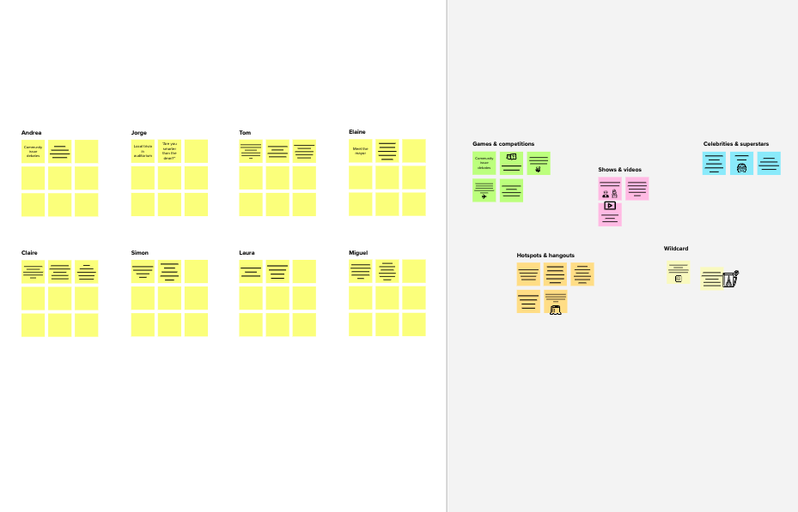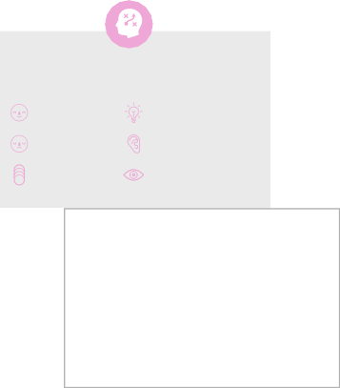

**Template**

###### Need some inspiration?

See a finished version of this template to kickstart your work.

[**Open example**](https://app.mural.co/template/e5a93b7b-49f2-48c9-afd7-a635d860eba6/93f1b98d-b2d2-4695-8e85-7e9c0d2fd9b9)